

**Configure Generic Routing Encapsulation (GRE***) v1.1*

# Introduction and/or Background

GRE provides a private path for transporting [multicast/routing protocols] packets through an otherwise public network by encapsulating (or tunneling) the packets. Packets travelling across the tunnel are not encrypted. GRE only encapsulates the packet with the addition of the GRE header.

# Objectives

In this project/lab the student will:

● Configure and verify GRE to create a private tunnel over the Internet

# Equipment/Supplies Needed

* Cisco Packet Tracer – PKA File included
* Routers (2)
* Switch (2)
* Computer (2)

# Assignment

Configure a GRE tunnel between 2 sites and verify its operation.

*Perform the steps in this lab in the order they are presented to you. Answer all questions and record the requested information inside of this lab document.*

**Configure Lab Network**

1. Configure the network as shown. If using Cisco Packet Tracer, the topology is created for you, you will just have to configure some of the interfaces.

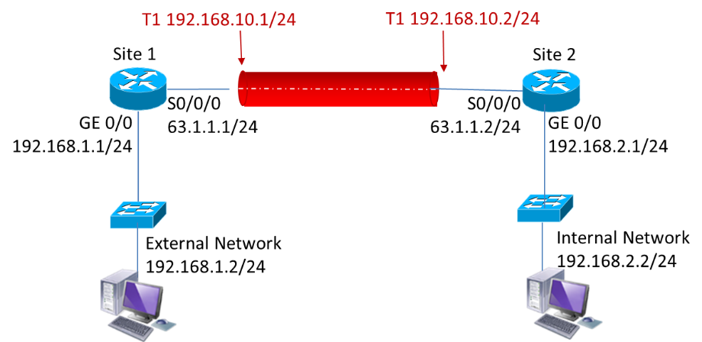

1. Configure the router’s (Site1, Site2) Serial and Ethernet interfaces as shown in the diagram.
2. Configure the TCP/IP settings on the Computers. Set the appropriate default gateway.

**Configure GRE**

1. Configure the tunnel between the two sites.

Site1(config)# **int tunnel1**

Site1(config-if)#**ip address 192.168.10.1 255.255.255.0**

Site1(config-if)# **tunnel source serial 0/0/0**

Site1(config-if)# **tunnel destination 63.1.1.2** Site1(config-if)#**exit**

Site2(config)# **int tunnel1**

Site2(config-if)#**ip address 192.168.10.2 255.255.255.0**

Site2(config-if)# **tunnel source serial 0/0/0**

Site2(config-if)# **tunnel destination 63.1.1.1** Site2(config-if)#**exit**

1. Workstations on either network will still not be able to reach the other side unless routing is configured. Configure static routes on both routers.

Site1(config)# **ip route 192.168.2.0 255.255.255.0 192.168.10.2**

Site2(config)# **ip route 192.168.1.0 255.255.255.0 192.168.10.1**

1. Verify the GRE Tunnel has been created properly with the following commands on each router.

Record the output of each command.

**Show ip interface brief**

Site1:

Site2:

**Show interface tunnel**

Site1:

Site2:

**Show ip route** (Note: On the routing table, the tunnel 0 interface shows up as a directly connected interface)

Site1:

Site2:

1. Test the configuration by pinging across the tunnel on both PCs from PC0 to PC1. Record the output.

PC0:

PC1:

1. Upload your completed running configuration(s) files or Packet Tracer file to the Instructor for grading in addition to any items recorded/documented throughout the lab.

**Rubric**

Checklist/Single Point Mastery

|  |  |  |
| --- | --- | --- |
| Concerns  Working Towards  Proficiency | Criteria  Standards for This  Competency | Accomplished  Evidence of Mastering Competency |
|  | Criteria #1: Site1 Router *show ip int brief* content  (10 points) |  |
|  | Criteria #2: Site2 Router *show ip int brief* content  (10 points) |  |
|  | Criteria #3: Site1 Router *show int tunnel 1* content  (20 points) |  |
|  | Criteria #4: Site2 Router *show int tunnel 1* content  (20 points) |  |
|  | Criteria #5: Site1 Router *show ip route* content  (10 points) |  |
|  | Criteria #6: Site2 Router *show ip route* content  (10 points) |  |
|  | Criteria #7: PC1 successful ping to PC2  (10 points) |  |
|  | Criteria #8: PC2 successful ping to PC1  (10 points) |  |